Tensile Testing
[Name]
Saginaw Valley State University
Department of Mechanical Engineering
Principles of Engineering Materials Laboratory (ME250L)

Abstract
The report contains the tensile test of Aluminium 7075 alloy using a tensile testing machine. The testing was done to determine the mechanical properties of the aluminium alloy. In the report, the true stress and engineering strain and stress were calculated and the stiffness of the testing machine. To understand the mechanical properties, the yield strength, the percentage elongation, ultimate tensile stress, and strength were also calculated. Heat treatment was also conducted between the alloy and discussion about the relationship between the cold and heated alloy were discussed in relation to the mechanical properties. Extensometer displacement and cross arm displacement were the two experimental methods that were analyzed to get a more accurate data collection method.
Keywords: Alluminium 7075, stress, strain

Tensile Testing
Introduction
Being the most abundant metal on earth, aluminium and its alloys are preferred in most engineering designs. The physical, chemical, mechanical properties of these aluminium alloys are suitable in different engineering disciplines (Kaufman 2001). This is because of their low density, high strength, and corrosion resistance. Therefore, it has to undergo engineering material testing to produce different mechanical properties that can be utilized in industries. Aluminium alloys are examples of such materials, and it has to undergo tensile and compression test for strength testing. Consequently, alloys such as aluminium which are ductile are subjected to annealing to soften them and make them less brittle (Davis 2004).
To determine the ultimate strength and strain to failure, the alloy has to undergo through the tensile machine. The surface at which the fracture occurs has to be observed by a microscope and analyze the fracture. This will help analyze the destructive standards of the alloy and use the fracture criterion for determining the failure. Apart from ultimate and yield tensile strength, the machine determines peak stress, the elongation, ductility, and the area reduction (Juijerm 2007).

Objectives
- To determine the yield strength, ultimate tensile strength, and elongation for aluminum samples in two different heat treat conditions
- To compare the use of crosshead and extensometer displacement measurements
- To examine how cold working increases the strength of an aluminum alloy

PROCEDURE
Three Aluminium specimen was provided.one cold worked the others heat annealed by air at 415 °C for three hours. Appendix B in the textbook provided literature data which was used for comparison purposes in the analysis section. Graphs of stress verse strain were constructed from this data, and the value of Young's modulus and strain hardened factor also noted.
The highest tensile strength of the machine at which it could operate at was calculated by dividing the cross-sectional area of the gage length of the test specimen. This is to prevent overload of the machine.
The data generated by the load cell was placed in a spreadsheet. Graphs of stress-strain were plotted from the data in the spreadsheet. The data and the graphs from the experiment were compared to literature values and comparisons drawn.
Drawbacks
The load cell is expensive and is at risks of overload.
The following formulas were used to generate additional data;
P = load
A_{o} = initial cross-sectional area of the specimen
s = engineering stress = P / A_{o}
L_{o} = gauge length measured on the specimen (4 inches)
∆ L = crossarm extension
e₁ = engineering strain measured from the crossarm displacement = ∆ L / L_{o}
L₂₀ = extensometer knife edge separation before tensile test (2 inches)
L₂ = extensometer knife edge separation at any time during the tensile test
e₂ = engineering strain measured from the extensometer = (L₂ - L₂₀) / L₂₀
True stress and strain were also calculated.
A = instantaneous cross-sectional area of the specimen
σ = true stress = P/A = s (e2 + 1)
ε ₁ = true strain measured by crossarm displacement = ln [(∆ L + L₀)/L₀] = ln (e₁ + 1)
ε ₂ = true strain measured by extensometer = ln (L₂/L₂₀) = ln (e₂ + 1)
The experiment was conducted in four steps. The first, cold worked aluminium was loaded to failure. The second, annealed aluminium was also loaded to failure. The next specimen was work hardened by loading it to yield point and finally it was loaded to failure.

RESULTS AND DISCUSSIONS
Below, Results from the cold worked 7075 aluminium which was loaded to failure are in the table.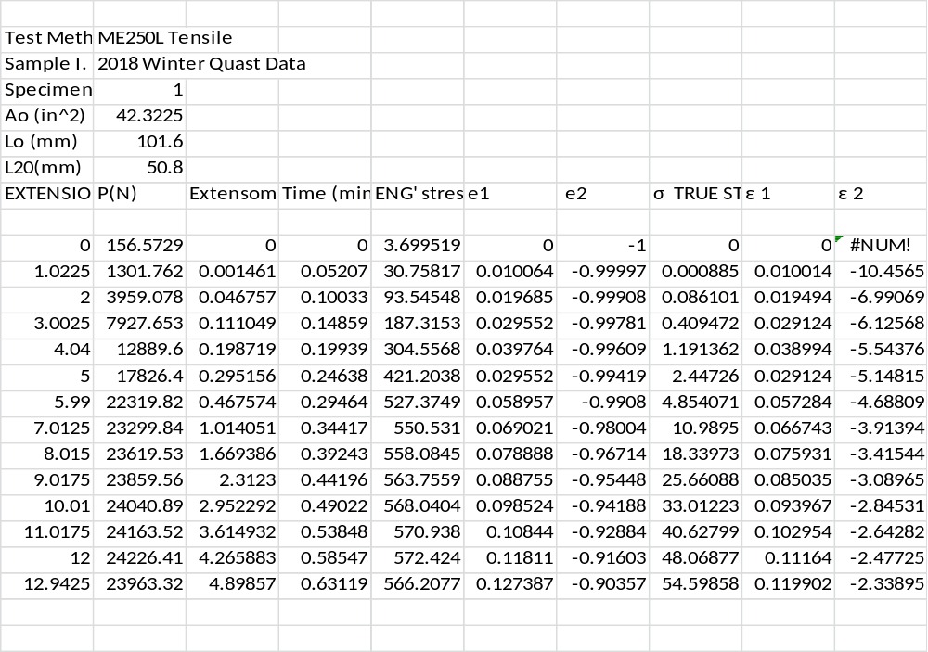
Table 1 sample 1 results

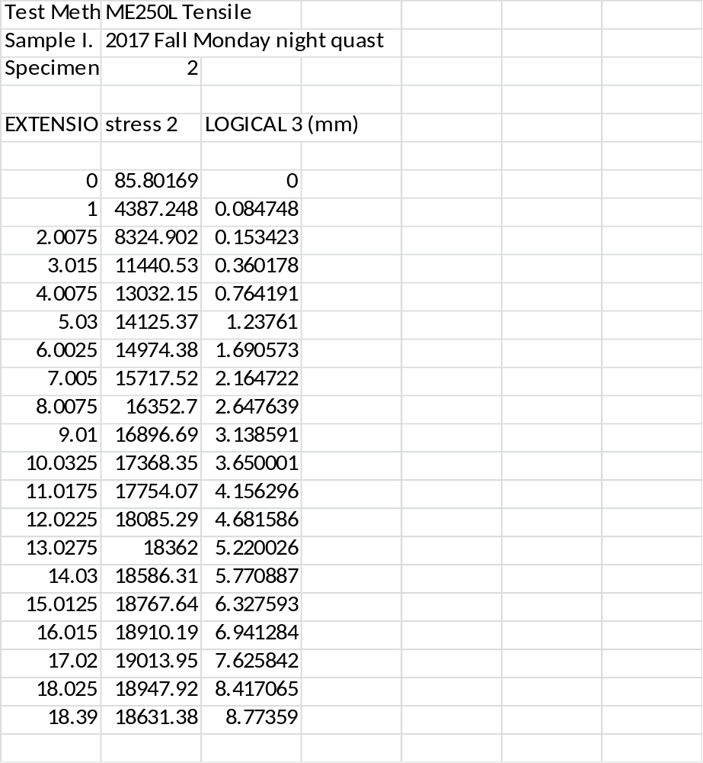
Table 2 sample 2 results

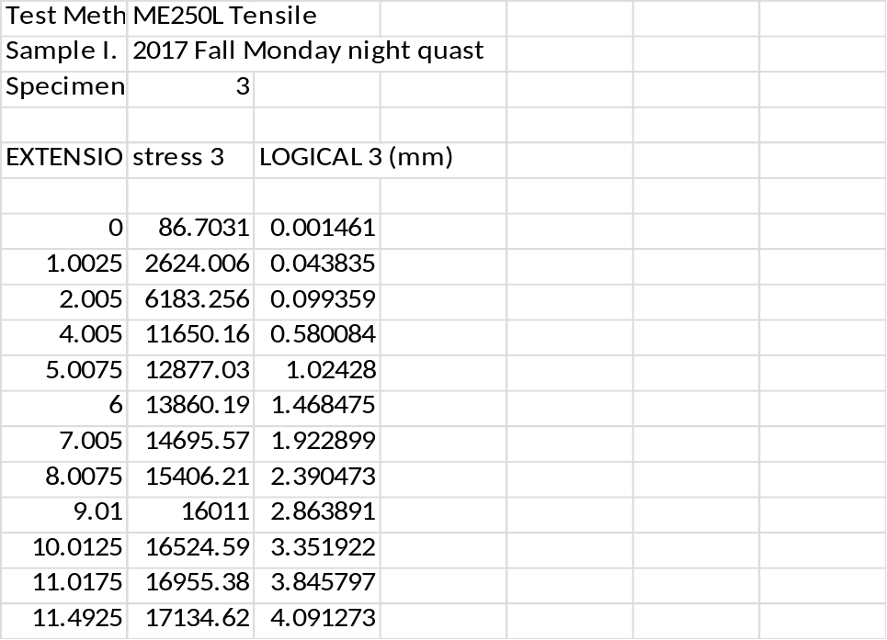
Table 3 sample 3 results

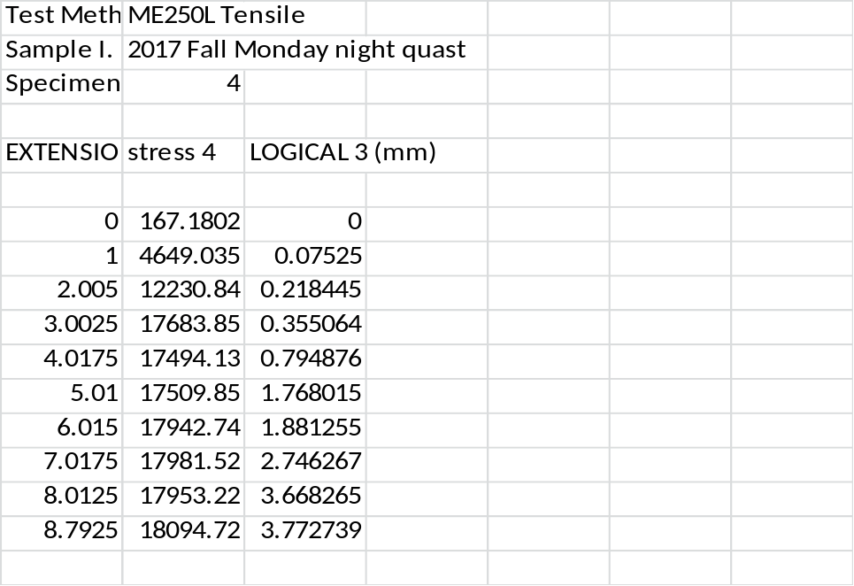
Table 4 sample 4 results

Figure 1 strain verse stress for sample 1 and sample2

Annealed aluminium has higher yield strength than cold worked aluminium. It also has a higher strain-to-failure factor. The superior qualities are due to the fact that the heating the aluminium eliminates some of the defects in the system as well as internal cracks and stresses, thus improving the overall mechanical properties of the aluminium.

Figure 2 true stress verses true strain
Work hardened aluminium 7075 which is sample4 offers the highest yield strength. This is because it was hardened, sample3, before loading it again. It also offers the highest strain hardening factor.
Sample 3has the highest ultimate strength. Because sample 3 does not undergo any stress prior to the main experiment it can sustain more stress. This explains why it has the highest ultimate strength.

Figure 3 stress and trues stress verse strain graph
The two graphs do not cross at the origin. Engineering stress and true stress are proportional to each other thus they never cross at any point.

Figure 4 strain verse engineering stress of sample 1
Young’s modulus (crossarm displacement);
$$E=\frac{stress}{strain}=slope=\frac{2376-399.4}{0.01949-0.01001}=208GPa$$
Young” modulus (extensometer displacement);
$$E=\frac{stress}{strain}=slope=\frac{2376-399.4}{-3.2347+3.9056}=2.9GPa$$

The values from the textbook are greater compared to the values of the experiment. The experimental values accommodate the defects of the test piece which could have been as a result of manufacturing defects. This, therefore, explains the difference between the two values. The extensometer measures the average displacement over the entire length of the specimen. This explains why its values are less compared to crossarm displacement and less accurate.
CONCLUSION
In this experiment, a tensile test was done on four pieces of aluminium 7075 and a finite element software used to determine their stress-strain relationships. Graphs from the data generated by the machine were used to plot graphs which aided in analyzing the mechanical properties of the specimens. Errors in the test could be eliminated by using well-calibrated instruments and precise measurement recording.
EXPERIMENTAL ERRORS
Errors could have occurred due to faulty loading machine; machine flexes, measurement recording errors and calibration errors.

References
Davis, J. R. (2004). Tensile testing. Materials Park, Ohio: ASM International.
Juijerm, P. (2007). Fatigue Behavior and Residual Stress Stability of Deep-Rolled Aluminium Alloys AA5083 and AA6110 at Elevated Temperature. Kassel: Kassel University Press GmbH.
Kaufman, J. G. (1999). Properties of aluminum alloys: Tensile, creep, and fatigue data at high and low temperatures. Materials Park, Ohio: ASM International.
Kaufman, J. G. (2001). Fracture resistance of aluminum alloys: Notch toughness, tear resistance, and fracture toughness. Washington, D.C: Aluminum Association.
Kaufman, J. G., & Rooy, E. L. (2004). Aluminum alloy castings: Properties, processes, and applications.

